Predicting Wine Quality Using Machine Learning: An Exploratory Study and Model Comparison

Group: 4

Names: Hemlatha Kaur Saran, George David Asirvatharaj, Raminder Singh

Module: Probability and Statistics for Artificial Intelligence

Course: Master in Applied Artificial Intelligence

Institution: University Of San Diego

Professor: Ms. Azka

Date: 20/06/2025

Table of Contents

Context 3

Data Cleaning and Preparation 3

Exploratory Data Analysis (EDA) 4

*Summary Statistics Table* 4

*Distribution plots for key features* 6

*Correlation matrix and key insights* 7

*Boxplots comparing quality with important features* 8

Model Selection 9

*Regression Model Performance* 10

*Classification Model Performance* 10

*Confusion Matrix* 10

Feature importance analysis 11

Summary plot 12

Conclusion and Recommendations 13

References: 14

Appendix: Python based Jupyter Notebook Code Details 15

**Predicting Wine Quality Using Machine Learning: An Exploratory Study and Model Comparison**

## Context

Assessing the quality of wine ahead of time is important for both winemakers and people buying wine since it helps adapt production and buying choices. Using machine learning methods, experts can connect the chemical aspects of wine with how wine is perceived so quality predictions can be made with data (Jain et al., 2023). To analyze the data, we use a set of white wines that has several chemical measurements, such as acidity, sugar, pH, and alcohol, together with an expert score. Scores for quality are between zero and ten, though they rarely go above eight. All of these features help to show the factors that affect how well a wine is made.

The main issue being investigated is the choice between predicting the exact quality score using regression or using classification to tell wines apart based on quality. Scores of 7 or higher designate good quality in this report. We aim to analyze the dataset, create different machine-learning models for both regression and classification, compare them, and measure their results (Bhardwaj et al., 2022). Machine learning methods, and more specifically, Random Forest models, can predict the quality of white wine using chemical information, which is helpful for both growers and wine drinkers.

## Data Cleaning and Preparation

In the first phase of analysis, we checked the dataset to see if any information was missing or incorrect. There are 12 columns in the white wine dataset: eleven feature columns with wine property information and just one target column for wine quality. Fixed acidity, volatile acidity, citric acid, residual sugar, chlorides, free sulfur dioxide, total sulfur dioxide, density, pH, sulphates, and alcohol content are part of the feature columns (Yavas et al., 2025). The quality variable, considered the target, is given as a number between 0 and 10.

The examination showed that NAs are not included in the dataset, so we can select a more straightforward way to preprocess the data and use all the observations provided. Since all the columns are the right types for their values, the dataset can be directly used in machine learning algorithms because numeric values are stored using float or integers (Singla et al., 2024). Since most distance-based and gradient-based machine learning models are affected by the input feature scale, each input feature was scaled to avoid this issue. The data was reshaped by standardization so that each feature has a mean of zero and a standard deviation of one. Doing this improves how the algorithms gather information and perform, primarily for Support Vector Machines and k-nearest Neighbors.

To perform classification, the continuous quality measurements were changed to binary classes. Any wine with a good quality score (7 or more) was placed in class 1 ("Good"), and any wine with a poor score (below 7) was put in class 0 ("Bad"). This boundary was chosen to highlight the difference between higher-quality wines and other samples, making the problem clearly useful for wine testers. Completing these steps makes the following data analysis and model-building much smoother.

## Exploratory Data Analysis (EDA)

### *Summary Statistics Table*

The data used contains 4,898 white wine samples that have a variety of chemical features. Most fixed acidity measurements are around 6.85, but they may be as low as 3.8 or as high as 14.2. Volatile acidity is usually 0.28, and most wines have alcohol levels of 8.4% to 14.2%, averaging 10.5%. Most wines are in the middle of the quality range, based on the fact that quality scores run from 3 to 9, with an average score of around 5.88. The fact that sulphates and pH do not always stay the same indicates they may affect the wine's flavor.

|  |  |  |  |  |  |  |  |
| --- | --- | --- | --- | --- | --- | --- | --- |
| **Feature** | **Mean** | **Std Dev** | **Min** | **25%** | **50%** | **75%** | **Max** |
| Fixed Acidity | 6.85 | 0.84 | 3.80 | 6.30 | 6.80 | 7.30 | 14.20 |
| Volatile Acidity | 0.28 | 0.10 | 0.08 | 0.21 | 0.26 | 0.32 | 1.10 |
| Citric Acid | 0.33 | 0.12 | 0.00 | 0.27 | 0.32 | 0.39 | 1.66 |
| Residual Sugar | 6.39 | 5.07 | 0.60 | 1.70 | 5.20 | 9.90 | 65.80 |
| Chlorides | 0.05 | 0.02 | 0.01 | 0.04 | 0.04 | 0.05 | 0.35 |
| Free Sulfur Dioxide | 35.31 | 17.01 | 2.00 | 23.00 | 34.00 | 46.00 | 289.00 |
| Total Sulfur Dioxide | 138.37 | 42.50 | 9.00 | 108.00 | 134.00 | 167.00 | 440.00 |
| Density | 0.99 | 0.003 | 0.99 | 0.99 | 0.99 | 0.99 | 1.04 |
| pH | 3.19 | 0.15 | 2.90 | 3.09 | 3.18 | 3.28 | 3.82 |
| Sulphates | 0.49 | 0.15 | 0.41 | 0.41 | 0.47 | 0.55 | 1.08 |
| Alcohol | 10.51 | 1.07 | 8.40 | 9.50 | 10.40 | 11.40 | 14.20 |
| Quality | 5.88 | 0.87 | 3.00 | 5.00 | 6.00 | 6.00 | 9.00 |

### *Distribution plots for key features*

Distribution plots highlight clear patterns in the most important physicochemical properties of white wine. For fixed acidity, volatile acidity, and citric acid, there are more cases with lower values and fewer with higher values, showing a distribution that is taller on the left than on the right. While most wines have little residual sugar, some samples end up with much higher sugar content. Chlorides and free sulfur dioxide exhibit a downward skewness. Density and pH data are found to be normally distributed. Moderate right skew in sulphates and alcohol shows that the vast majority of wines are in the middle ranges. However, a few outliers reach higher levels. They reveal the important role played by the different chemicals in making wine.

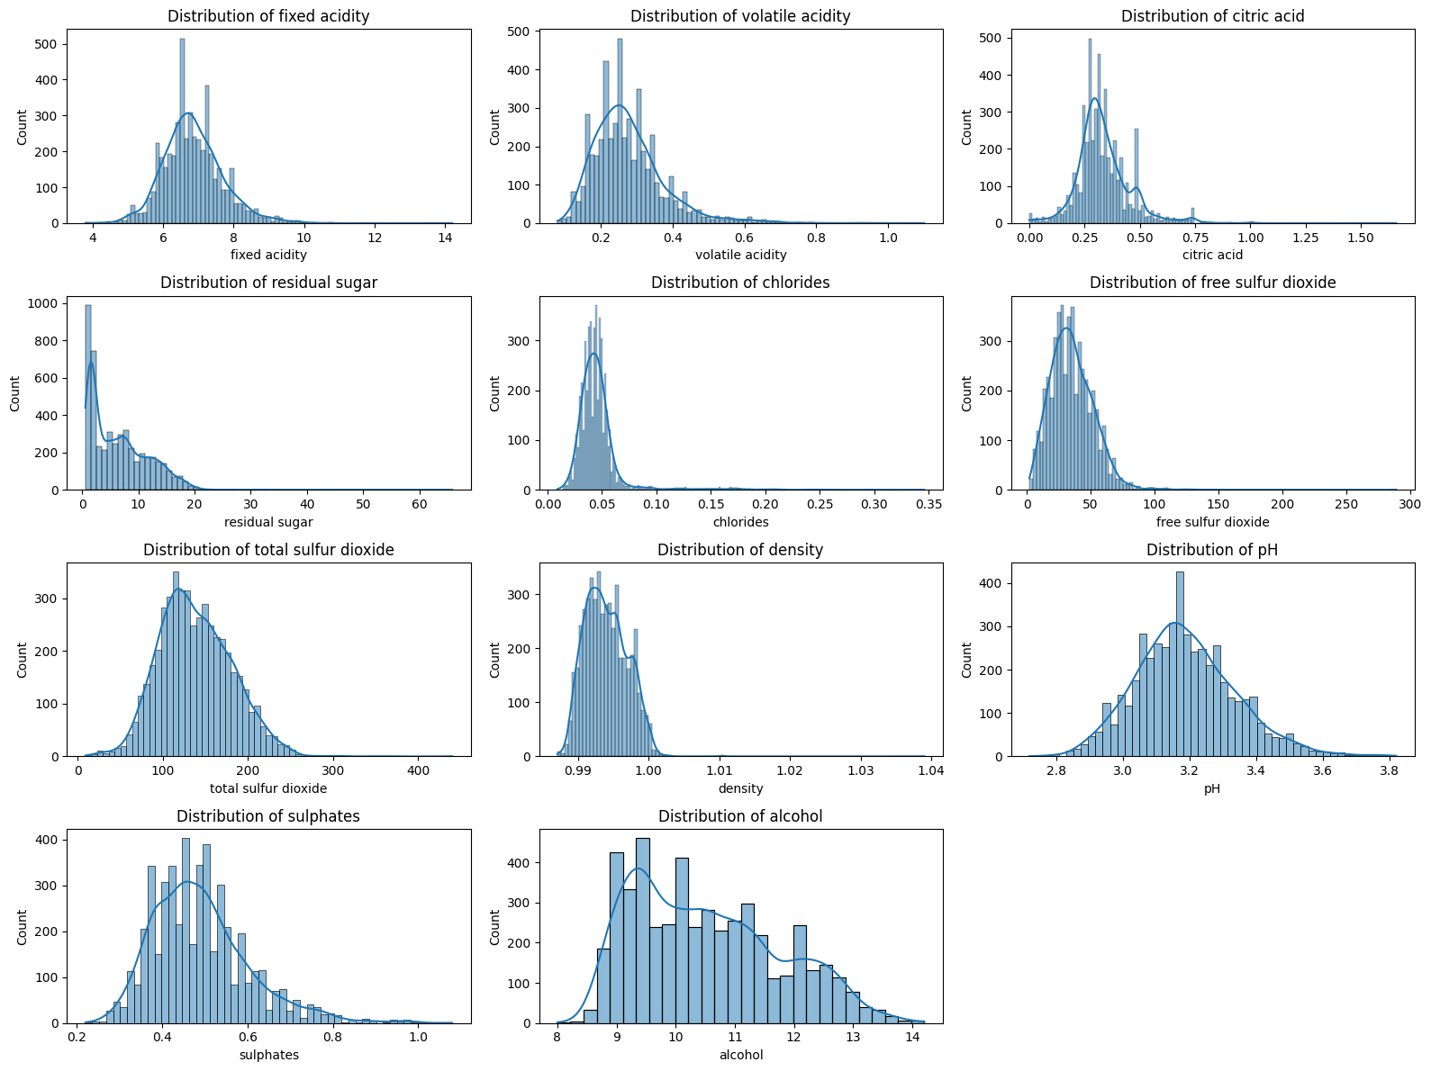

### *Correlation matrix and key insights*

The correlation matrix demonstrates the relationship between different wine properties and quality. A strong and positive relationship (0.44) exists between higher alcohol content and increased perceived quality. Denser wines and those containing more sugar appeared to score slightly lower on the quality scale. Higher levels of volatile acidity than normal (-0.19) connect with lower wine quality ratings, confirming that acidity may make wine less appealing. Similarly, my data showed that individual factors have only limited links with quality, implying that several variables play a role in shaping wine quality.

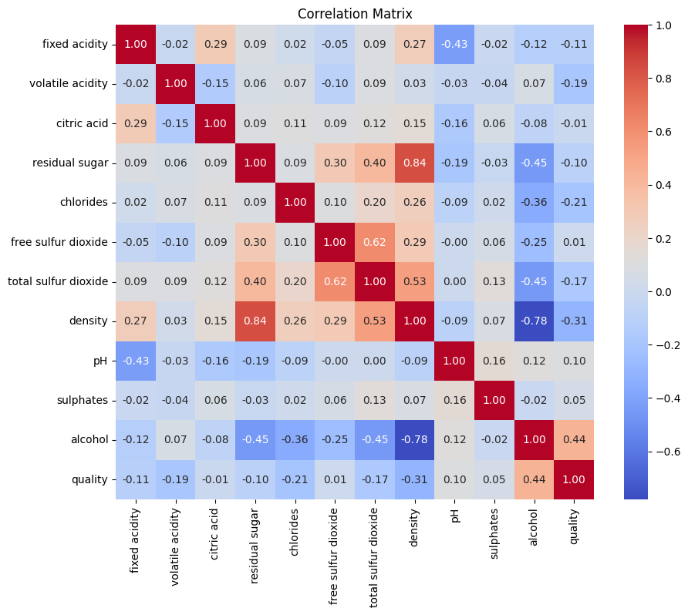

### *Boxplots comparing quality with important features*

The boxplots reveal that multiple chemical measurements are linked to the quality of the wine. The best wines usually contain higher amounts of alcohol than lesser qualities. Sulphate levels often go up a bit as quality goes up, though the variation is wider. Reducing volatile acidity is important for a higher wine grade, so lower acidity is better in fine wines. Citric acid appears to have limited variation according to quality, which suggests it matters less than the other compounds. Generally, these plots make it clear that alcohol, sulphates, and volatile acidity play a key role in determining wine quality.

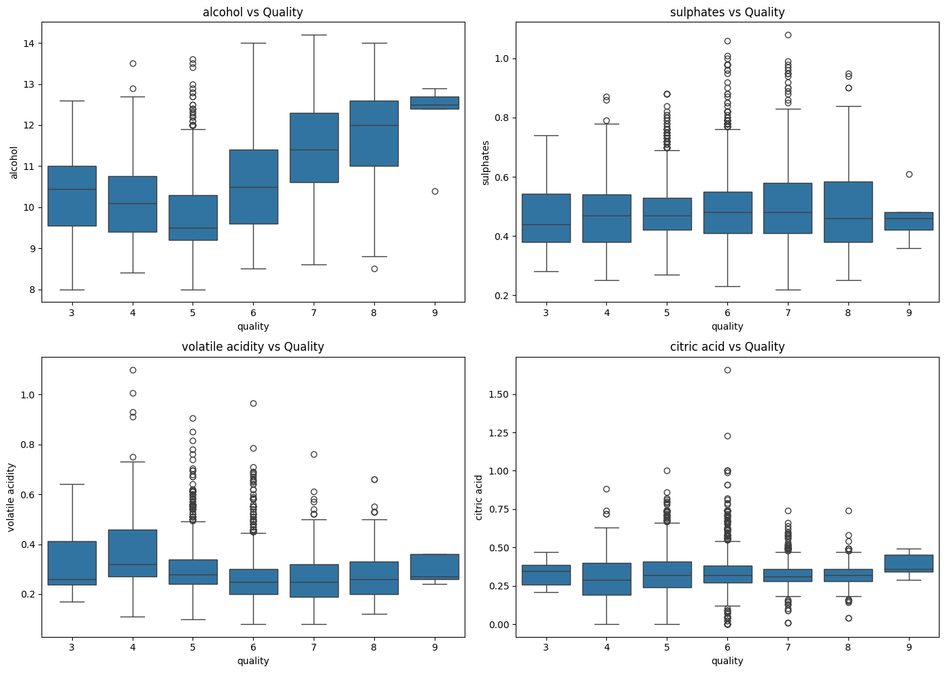

## Model Selection

The project involved investigating and solving problems of the types of regression and classification. In regression, we tried to estimate the wine quality, while in classification, we marked wines as Good or Bad if their score was higher or lower than 7. The regression approach and the tested models for predicting quality values are at the center of this section.

Three models were tested: Linear Regression, Random Forest Regressor, and XGBoost Regressor. The fact that Linear Regression is simple and easy to explain is why it is considered the first model. However, it considers that features and the target are linked linearly, though this may not be sufficient for wine quality data. Because the Random Forest Regressor is an ensemble of trees, it handles nonlinear problems and multiple interactions and tends to improve accuracy. Another important type of ensemble method, XGBoost, applies gradient boosting and usually performs well on structured information due to its strong optimization and regularization.

All models were trained on the same set of standardized features so that fair comparisons and better averaging could be made, which matters most for linear and gradient-based models. When cross-validation was possible, the code performed tuning of the hyperparameters. Baseline results for Random Forest and XGBoost were established using the default parameters, and we may expand tuning using grid search later on. You hardly need to configure Linear Regression.

Evaluation of the models took into account three regression indicators: Root Mean Squared Error (RMSE), Mean Absolute Error (MAE), and R-squared (R²). They measure how accurate the predictions are and the number of changes in the dataset that the model can explain. Out of all models examined, Random Forest was the most effective with a low RMSE (0.590), a low MAE (0.419), and a good R² (0.551) and was just ahead of XGBoost. Results from Linear Regression supported the idea that nonlinear techniques work better with the dataset.

### *Regression Model Performance*

|  |  |  |  |
| --- | --- | --- | --- |
| **Model** | **RMSE** | **MAE** | **R²** |
| Linear Regression | 0.754 | 0.586 | 0.265 |
| Random Forest | 0.590 | 0.419 | 0.551 |
| XGBoost | 0.617 | 0.439 | 0.509 |

### *Classification Model Performance*

The classification task focused on comparing "Good" wines (quality ≥ 7) with "Bad" wines using logistic regression, Random Forest, and XGBoost classifiers. The highest accuracy (0.893), precision (0.859), recall (0.643), and F1-score (0.736) were achieved by Random Forest. XGBoost appeared next and recorded 0.883 average accuracy and 0.724 F1-score, but it did better than average at finding positive cases. Logistic regression fell behind in recall (0.282) and F1-score (0.380), suggesting that its results were strongly affected by the class imbalance. They suggest that combining different models is effective in handling this classifying task.

|  |  |  |  |  |
| --- | --- | --- | --- | --- |
| **Model** | **Accuracy** | **Precision** | **Recall** | **F1-score** |
| Logistic Regression | 0.787 | 0.582 | 0.282 | 0.380 |
| Random Forest | 0.893 | 0.859 | 0.643 | 0.736 |
| XGBoost | 0.883 | 0.795 | 0.665 | 0.724 |

### *Confusion Matrix*

The confusion matrix for the Random Forest classifier shows that out of the total samples, 729 wines were correctly classified as "Bad" (true negatives), and 146 wines were correctly identified as "Good" (true positives). However, 24 "Bad" wines were misclassified as "Good" (false positives), and 81 "Good" wines were misclassified as "Bad" (false negatives). This indicates that the model performs well overall but misses some high-quality wines, highlighting a trade-off between precision and recall.

|  |  |  |
| --- | --- | --- |
|  | **Predicted Bad** | **Predicted Good** |
| Actual Bad | 729 | 24 |
| Actual Good | 81 | 146 |

## Feature importance analysis

Feature importance plot illustrates how each physicochemical property affects the prediction of wine quality. Alcohol has a much bigger impact than any other factor in this analysis. This agrees with research that shows a good connection between alcohol concentration and the taste of a wine. The following most relevant features are free sulfur dioxide and volatile acidity due to their strong role in quality predictions. The role of sulphates and chlorides is small, whereas residual sugar and pH are medium factors. The findings indicate that several key chemicals determine wine quality, not just one element.

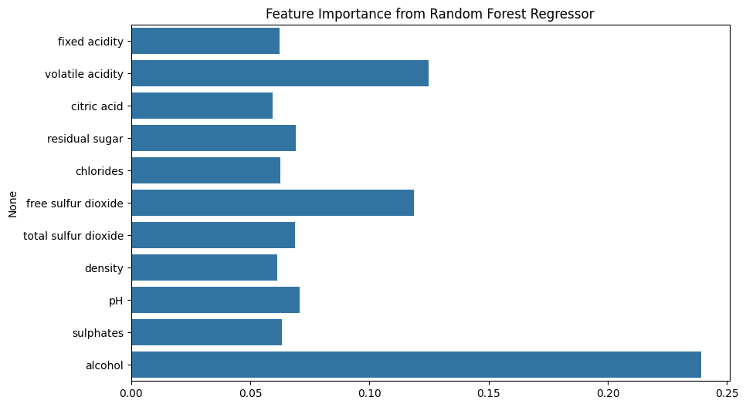

## Summary plot

The SHAP summary plot illustrates how every individual feature supports or influences the model's judgments on wine quality. The most significant benefit comes from alcohol, which means higher levels raise the predictions for better quality. Volatile acidity affects quality in a bad way, and elevated acidity leads to a lower predicted score. Sulfur dioxide and residual sugar sometimes increase and sometimes decrease how accurately we can make predictions from the data. Less severe but still obvious impacts can be seen when focusing on pH, chlorides, and sulphates. This gradient makes it clear that extreme values in the data can result in significant changes in the model's output because of the many connections between variables.

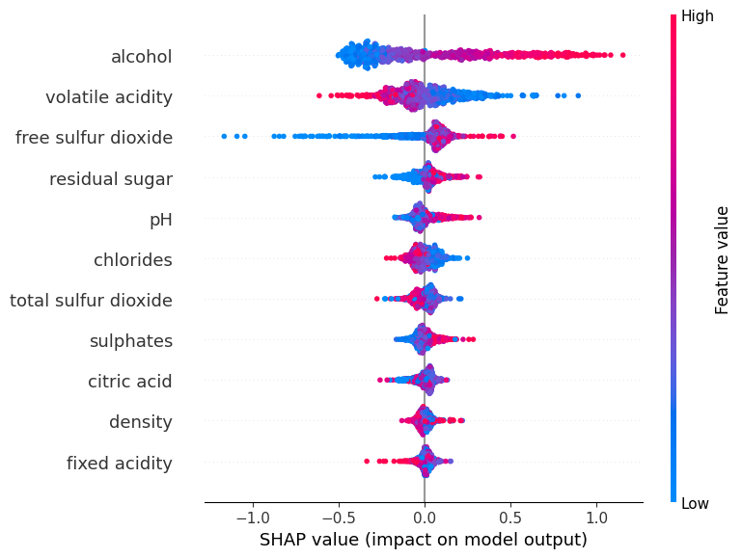

## Conclusion and Recommendations

The research focused on using machine learning to foresee the quality of white wines using their biophysical properties. When the wine was first examined, significant associations with quality were found for alcohol content, volatile acidity, and sulphates. According to the data, better quality wines were associated with higher alcohol content, while higher volatile acidity was seen to lower quality scores. Multiple models were tested for both regression and classification, and it was found that Random Forest and XGBoost worked better than the simpler models, Linear and Logistic Regression.

Of the regression models, Random Forest scored the highest in both accuracy and stability, showing an RMSE of 0.59 and explaining nearly 60% of quality differences among samples. To separate high-quality wines from the others, Random Forest did exceptionally well, with accuracy approaching 90% and a reliable F1 score. From these results, I conclude that these models can effectively handle the complicated and nonlinear patterns found in wine quality information.

To improve further, researchers might try out more hyperparameter settings and also test Support Vector Machines or neural networks. Using both this data and sensory or expert review data could help improve the tool's prediction rate. Techniques such as adjusting features or dropping unnecessary ones can improve the performance and clarity of the model. The results show that machine learning can effectively predict wine quality by using data. It serves winemakers by helping them manage quality and consumers by ensuring they know what they are purchasing. With additional work in this field, we are poised to uncover more about how the qualities of wine link to its quality.

## References

Bhardwaj, P., Tiwari, P., Olejar Jr, K., Parr, W., & Kulasiri, D. (2022). A machine learning application in wine quality prediction. *Machine Learning with Applications*, *8*, 100261. <https://www.sciencedirect.com/science/article/pii/S266682702200007X>

Jain, K., Kaushik, K., Gupta, S. K., Mahajan, S., & Kadry, S. (2023). Machine learning-based predictive modelling for the enhancement of wine quality. *Scientific Reports*, *13*(1), 17042. <https://www.nature.com/articles/s41598-023-44111-9>

Singla, M., Gill, K. S., Upadhyay, D., & Singh, V. (2024, March). Exploratory Data Analysis for Red Wine Quality Prediction Using a Decision Tree Approach and Machine Learning Methods. In *2024 3rd International Conference for Innovation in Technology (INOCON)* (pp. 1-5). IEEE. <https://ieeexplore.ieee.org/abstract/document/10511597/>

Yavas, C. E., Kim, J., Chen, L., Kadlec, C., & Ji, Y. (2025). Exploring Predictive Modeling for Food Quality Enhancement: A Case Study on Wine. *Big Data and Cognitive Computing*, *9*(3), 55. <https://search.proquest.com/openview/b1b2835dcbec953cd523e86aebc40f29/1?pq-origsite=gscholar&cbl=2061777>

## Appendix: Python based Jupyter Notebook Code Details

**GitHub Repo url**: <https://github.com/ramindersinghusd/m7>